Revised Techno-Commercial Offer
For

KESAR ENGINEERING., Faridabad(Haryana)
POWDER COATING PLANT
21st December 2024

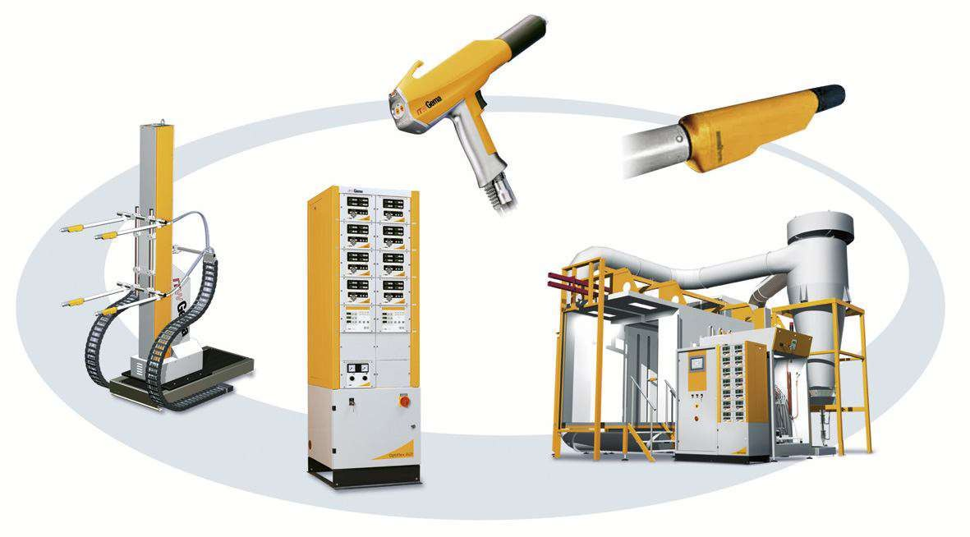

M/S Kesar Engineering.

Kind Attn. : Mr.Kesar Dagar

Subject : Your Requirement of “POWDER COATING PLANT”

Dear Sir,

We thank you for the courtesy and interest shown in our organization & products. Further based on the discussion held with you and based on the technical data provided by you, we are submitting our Techno-Commercial proposal for the subject captioned above.

We hope you will find our technical offer meeting with your requirements and you will favour us with your valuable Order.

Please feel free to contact us for further clarifications, if any. Look forward your valuable Order at the earliest.

Thanking You

Yours faithfully,
For Value Added Coating Solution Pvt. Ltd.

HARISH SHARMA
Mob: (+91) 9811846214
Email: harish@optifinish.in

TABLE OF CONTENTS
- VALUE ADDITION WITH VACSPL 4
- SCOPE OF SUPPLY 4
- TECHNICAL DESCRIPTION 4
  - POWDER COATING BOOTH WITH MONO CYCLONE & DUST COLLECTOR 4
  - CAMEL BACK TYPE POWDER CURING OVEN 5
  - MATERIAL HANDLING OVER HEAD CONVEYOR SYSTEM 6
  - ELECTRICAL CONTROL PANEL 7
- COMMERICIAL OFFER FOR POWDER COATING PLANT 8
- DELIVERY & PAYMENT TERMS 8
- EXCLUSIONS 9
- UTILITY PROVIDED BY CUSTOMER 10

VALUE ADDITION WITH VACSPL
  - Leader & Legend - VACSPL pioneered the powder coating technology in India.
  - Constant efforts towards developing better technology in surface coating at our R & D base.
  - Easy availability of spares assures continuous production.
  - Prompt service from our sales and service offices at Ghaziabad, Gurgaon and Rudrapur, who are technically competent to handle any eventuality.

SCOPE OF SUPPLY

S. No. | Item | Unit
1. | Powder Coating Booth | 01 Set
2. | Mono Cyclone Recovery Unit | 01 Set
3. | Post Cartridge Filter Unit (Dust Collector) | 01 Set
4. | Camel Back Type Powder Curing Oven | 01 Set
5. | Material Handling Overhead Conveyor | 01 Set
6. | Electrical Control Panel with Field Wiring | 01 Set
7. | Paint & Finishing | 01 Lot
8. | Erection & Commissioning | 01 Job

TECHNICAL DESCRIPTION

POWDER COATING BOOTH WITH MONO CYCLONE & DUST COLLECTOR

S. No. | Item | Description
1. | Type of application | Automatic- Back to Back type
2. | No. of enclosure | 01 Set
3. | Powder recovery system | Mono cyclone with Post cartridge filter
4. | Overall Dimensions | 5000 x 1500 x 3150 mm approx.
5. | Material of Construction | - SS-304 Sheet 1.20 & 1.50 mm Thick with MS base & support structure.  - Mono Cyclone and Post Cartridge Unit in MS.
6. | Post Filter type | Pulse Jet cleaning cartridge filter
7. | Exhaust Blower | On the top of Post cartridge filter unit
8. | Exhaust blower’s capacity | 10,000 cmh approx.
9. | No. of Cartridge Filter | 09 No’s
10. | Capacity of Cartridge Filter | 1000 CM/H each

11. | MOC | Polyester fleece
12. | No. of Solenoid Valve | 09 No’s
13. | No. of Air Filters | 04 No’s
14. | Illuminations | 600-800 Lux
15. | Painting scheme | Primer followed by finish synthetic enamel paint.

CAMEL BACK TYPE POWDER CURING OVEN
The oven is made of an insulated sheet metal enclosure in which hot air is circulated through a heat exchanger. Blower is provided to circulate the hot air. Hot air is distributed inside the oven through ducting. GI fabricated louvers are provided to adjust the flow & direction of hot air inside oven. Insulated panels are made of GI sheet metal formed into panels of cassette construction. One panel is joined to the other panel with the male female type construction. Proper reinforcement is provided to make panels rigid.

S. No. | Item | Description
1. | Quantity | 1 Set
2. | Process | Powder Curing
3. | Type | Camel Back Oven
4. | Material Handling | Overhead conveyor
5. | Heating source | LPG/PNG
6. | Design Temperature | 240 °C
7. | Working temperature | 180-200 °C
8. | Temperature controller | Digital single set point ON/OFF control with PT-100 sensor
9. | Overall dimensions | 11850 x6110 x 2890 mm (L, W, H) approx.
10. | Curing schedule | EMT – 10~12 min @ 180-200 °C  Residence time – 16~20 min @ 180-200 °C
11. | Residence time | 18 minutes @ 1500 mm/min. conveyor speed  20 minutes @ 1000 mm/min. conveyor speed
12. | Construction type | Male-Female type GI Insulated Panels with stiffeners
13. | Thermal insulation | 150 mm thick Rockwool slabs (resin bonded) having 96 kg/cum density, duly fitted; silicon sealant applied between  the panel joints.
14. | Heat Load | 3,30,000 kcal/hr approx.
15. | Hot air circulation blower | Reverse blade type, V-belt driven duly protected with fan  casing for proper in directional flow of air.
16. | HAC fan capacity | 44,000 cm/h approx.
17. | Air delivery duct | Shall be provided at the bottom of the oven throughout its  cross section. The duct shall have properly placed louvers to

 |  | get the uniform air all through the oven.
18. | Safety Interlock | Shall be provided for blower & heaters
19. | Painting | One coat of primer followed by finish synthetic enamel paint

MATERIAL HANDLING OVER HEAD CONVEYOR SYSTEM

S. No. | Item | Description
1. | Conveyor Length | 120-125 meters approx.
2. | Type of Conveyor | Close track type Overhead conveyor
3. | Chain Link Pitch | 100 mm
4. | Hanging Pitch | 200 mm & its multiple
5. | Component Pitch | 800 mm
6. | Load capacity | 40 kg per hanger
7. | Speed | 2.5 – 3.0 Meter/Minute (Variable by VFD)
8. | Drive unit | Caterpillar type
9. | Lubrication Unit | Air Mist Lubricator type
10. | Tensioning Unit Set | Screw Type
11. | Overload Safety | Mechanical shear pin arrangement
12. | Supporting structure | The conveyor will be supported from ground
13. | Paint and finishing | The track will be Orange
14. | Control Panel | 440-volt AC with Linear speed indicator & VFD
15. | Motor protection | Over load relay for High current in Control panel and  Thermostat to trip Motor at High temperature.
16. | Load bar & Hangers | Excluded

ELECTRICAL CONTROL PANEL
The Control Panel consists of controls for Powder Curing Oven, Powder Coating Booth, separate controllers for Post filter unit & all other electromechanical equipment supplied in the complete Powder Coating Plant. The Cabinet is made up of MS Sheets duly powder coated & supported by suitable structure.
All supplied items will be of reputed makes.
The Controls will be as follows:
    - Mains On/Off Switch Fuse Unit
    - Blower motors Start/ Stop with ‘ON’ Indication & 3 Pole MCBS
    - Voltmeter with selector switch
    - Ammeter with selector switch
    - Temperature indicators cum controllers for Oven & Flue Gas Temperature
    - Burner Start / Stop with ON Indication & ON Delay Timer
    - Motor Protection Relays
    - Emergency Stop
    - Interlocks between oven blower & burner
    - Interconnections
Note:
- Incoming & Outgoing cables from top side of control panel.
- Cabinet will be powder coated in Siemens Grey & Bottom frame in black color.
- For Blower Star/Delta Starters are considered.
- Cables will be laid overhead in suitable cable trays with proper supports wherever necessary.
- All Switchgear/Contactors/Pushbuttons will be of Siemens make.
- For control panels minimum clearance of 1000 mm is recommended from all sides.
- Mains Supply Considered – 3 phase, 4 wire with Neutral 400 V AC, 50 Hz. (Same to be provided by Customer)
- Proper Earthing to control Panel (Same to be provided by Customer)

COMMERICIAL OFFER FOR POWDER COATING PLANT

S. No. | Item Description | UOM | BOM |  | AMOUNT
1. | POWDER COATING PLANT  (As per scope of supply from 1-7) | LOT | 1 | INR | 49,00,000
2. | ERECTION & COMMISSIONING | JOB | 1 | INR | 1,00,000
TOTAL PROJECT COST |  |  |  | INR | 50,00,000

DELIVERY & PAYMENT TERMS

1. | Price Basis | Ex works, Noida
2. | Freight | Extra
3. | Packing (If required) | Included
4. | Transit Insurance | Extra
5. | GST | Extra
6. | Delivery | 10-12 weeks from the date of PO with advance
7. | Erection | 6-8 weeks
8. | Commissioning | 1 week
9. | Advance along with PO | 50%
10. | Against Inspection (PI) | 40% Basic + 100% Taxes
11. | Against Commissioning | 10%
12. | Delivery Condition | Dismantle, partly pre-assembled.
13. | Warranty | 18 months from the date of Supply or 12 months from date of  commissioning whichever is earlier.
14. | Limitation | Our liability limited to design, manufacture and supply and  installation of Plant as per enclosed scope and specs.
15. | Deserve to modification | We reserve the right to alter the plant design without  Deteriorating the utility, performance and operating safety.
16. | Right of Reserve | This Quotation is the Sole Property of VACSPL and should not be handed over to Third Party without permission from  VACSPL.
17. | Quotation Validity | 15 days

EXCLUSIONS
  - Civil Work
  - Jig & Hangers
  - All Chimney Structure
  - Roof opening & Closing for Exhaust ducts.
  - Air Supply for Auto Air Zone
  - Pit for Drain, trench
  - LPG pipe line with Filter and Regulator up to Burners.
  - Incoming power Supply for Control panels with Earthing.
  - Earthing at All panels, structure, Ovens separately
  - Stands for Jigs/Fixture, Jigs
  - Material moving Trolley
  - Material Unloading/Shifting/Cranes at site.
  - Materials shifting up to Shop floor.
  - Platform for Fume Exhaust System
  - Uniform floor level in Plant area - +/- 10 mm
  - Free power at the time of Installation and commissioning.
  - Shop floor lighting
  - Floor painting
  - Any other items required which are not stated in our offer.

UTILITY PROVIDED BY CUSTOMER
- Electricity

  - Power – 415 V + / - 5 %, 3 phase, 50 Hz + / - 2 %, 4 wire AC supply.
  - Control – 230 V + / - 5 %, single phase, 50 Hz + / - %, 2 wire AC supply.

- Compressed air of following quality and quantity

  - Dirt – lum – 1 mg / N m 3 max.
  - Water content – < 1.3 gm / Nm3; - 40 deg C p d p.
  - Oil content – < 0.1 mg / Nm3.
  - Pressure – @ 7 bar.
  - Qty. Will be provided later.

- Fuel for Heating System

  - Type – LPG/Propane/NG (Client to confirm any one)

Note: Net calorific value of LPG considered 11500 Kcal/Kg Above fuel consumption figures are under worst ambient condition @ 7.5 0 C

- Quality and Quantity of Water

  - Pressure at inlet to tank – 1.5 kg / cm 2 g. minimum.
  - Quality of water for Pre-treatment Plant. (To be consulted with chemical supplier) Notes:
- Batch requirement of water will be equal to the volume of the Tank & Continuous quantities is to be given by the chemical supplier.
- Water quantities required during initial cleaning and commissioning would be about 4 to 5 times of initial fill up quantities. Customer to take care of the same.
Notes:
  - Customer to provide above utilities free of cost during erection/trial/pre- commissioning/commissioning period.
  - All Utilities to be provided by client at the points required by VACSPL. All the control panels to be charged with MCCB and earthing to be provided by Client.

Note: The above values of utilities are tentative and may change during detail designing.

THANK YOU
FOR ANY ENQUIRY PLEASE CONTACT


Opti finish

HARISH SHARMA
Mobile: (+91) 9811846214
Email: Sales@optifinish.in

